Combe Pre-school Newsletter Summer Term 5 2025



Tuesday 22nd April – Pre-school starts at 8.50am and Earth Day,

Monday 5th May – Bank Holiday,

Thursday 8th May – Charity Dress Up Day,

Tuesday 20th May – World Bee Day,

Friday 23rd May – Inset Day pre-school closed,

Monday 26th May to Friday 30th May – Half term pre-school closed,

Monday 2nd June- Term 6 starts at 8.50am.

Welcome Back

Welcome back to the start of the new term. We would like to give a warm welcome to Kitt and his family who will be joining us this term. We hope Kitt enjoys his time with us and makes lots of new friends.

Funding Forms

Please ensure your child’s funding form is returned by Tuesday 22nd April, if possible.

School Dinners

Remember to book you child’s school dinner for this term.

Session Request Forms for September 2025

An email with a session request form has been sent to the parents of the children who will be staying with us next year. Please can you return the form by Wednesday 23rd April. Sessions for the Autumn term will be confirmed before the end of the summer term.

A World Book Day Thank You

We would like to say a BIG thank you to everyone who donated money on our World Book Day dressing up event. We raised an amazing £48.50p which we have used to purchase some number bee stones and some other bee resources (pictured below) to help the children with their maths and promote sensory play and to help us celebrate World Bee Day on 20th May.

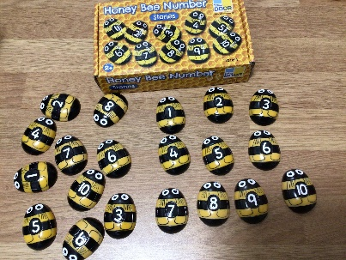 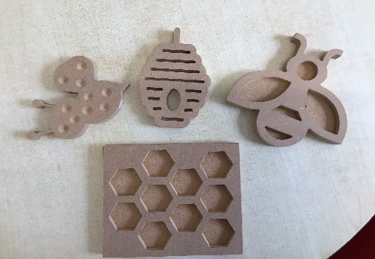

Earth Day Tuesday 22nd April

Earth Day is annual event to promote environmental protection with events happening in 190 different countries. This year’s theme is to “Invest in Our Planet” which urges us to spend some of our time, resources and energy into resolving the climate crisis. We hope to join in at pre-school by planting some wildflower seeds along with some sunflowers, Ladybird poppies and nasturtium seeds to help attract bees and butterflies into our garden. To find out more about Earth Day please click on this link.

[Earth Day 2025 | Activities & Resources for April 22 - Earth Day](https://www.earthday.org/earth-day-2025/)

We will continue to celebrate nature this term by looking at the life cycle of frogs, as well as learning about butterflies and celebrating World Bee Day (20th May) and learning about how and why we should be encouraging them into our gardens.

We have also brought a bee home to put in our garden area and we hope to observe them and use a chart to help us identify what types of butterflies and bees that we see in the garden area soon.

A new bird bath is a welcome addition into our garden area to invite small birds, bees and butterflies to stop and have a drink.

Healthy Smiles Accreditation

Our current Healthy Smiles Accreditation ran out in March, so we will be working towards achieving this again during April and May. We may have to ask you to fill in a small questionnaire about your child’s dentist and when your child last attended, and we will be sharing lots of information on how you can promote oral health and hygiene at home to help prevent tooth decay. The staff will be undergoing a 90-minute training session to update their knowledge on the importance of tooth brushing and we will be planning some oral health activities to do with your children to help them learn about the importance of looking after their teeth and eating healthily. We will let you know when we have successfully completed the accreditation.

Crackerjacks Charity Dress Up Day

On Thursday 8th May we will be holding a dress up day to raise vital funds to support a child who has Muscular Dystrophy and in need of a Motorised Trike, which will allow her to go on outings with her family.

For a small donation your child can come to pre-school dressed up for the day. We will be explaining to the children about what and who we will be raising the money for. Alongside this we may read some stories around disabled people so the children can learn about disabilities and how they affect children and adults in their everyday lives. If you would like to fill in a gift aid declaration form, then please ask Andrea for a printed form.

If you want to find out more about the Crackerjacks Charity, the please look at their website [www.crackerjacks.org.uk](http://www.crackerjacks.org.uk)

**Book Lending Library**

We have added some new books to our library, so please have a look.

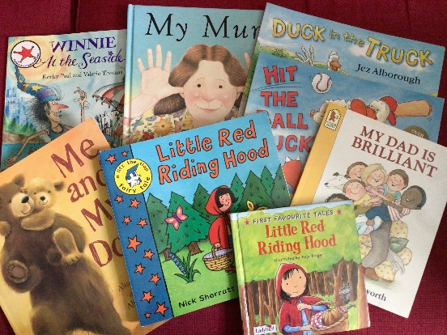

**Woodwork**

We have recently purchased some woodworking equipment and some wood so the children can learn to use some new tools and learn new skills, as well as encouraging their creativity. The children will be supervised in very small groups to ensure their safety when joining in this fun activity.

**Easyfundraising**

If you are shopping online, then you can still help us raise funds for our Pre-school a by creating an account and visiting retailers through this site. Companies will donate a percentage of money to our Pre-school if you use this site whilst shopping online. You can access the link via our website or by visiting <http://www.easyfundraising.org.uk/?v=c>.

**Website**

Events, calendar dates and newsletters can be viewed on our website, as we update this regularly.

**Facebook page**

To keep up-to-date with events and news from our Pre-school then please take a look and like our face book page which can be found at <https://www.facebook.com/combepreschoolandafterschool>. Don’t forget to like us!

Thank You for taking the time to read our newsletter!

Best Wishes

From

Andrea, Lisa, Anne-Marie, Kate, Becky, Chloe, Lydia, Sophie and Harriet.