

Combe Pre-school Newsletter Spring Term 4 2025



Monday 24th February – Term starts at 8.50am.

Wednesday 26th February – Clothes collection 9am,

Friday 4th April – End of term at 11.50am,

Monday 7th April to Friday 18th April – Easter Holidays,

Monday 21st April – Bank Holiday,

Tuesday 22nd April – Summer Term 5 starts.

**Jo’s Last Day**

We said a sad goodbye to Jo at the end of last term and gave her a lovely card and a present to say Thank you for all the hard work she has done, especially the wonderful cooking activities she has done with the children. We will all miss her and wish her all the best for the future.

**Staff Training**

Both Sophie and Harriet have started training towards a Level 3 qualification, and we wish them the best of luck with the course which requires a lot of hard work and dedication.

**Woodland Explorers**

Our Woodland Explorers session will start on Monday 3rd March weather permitting.

**Session Increase for children**

If you would like to increase your child’s sessions after the Easter holiday, then please email Andrea to check available of spaces for your child.

**World Book Day – Thursday 6th March**

We will be celebrating World book on 6th March, where we will be organising some fun activities based on some popular books. For a small donation, your child is welcome to dress up for the day. We are hoping to raise some funds to purchase some number bees to help improve our maths resources for the children (see picture below).

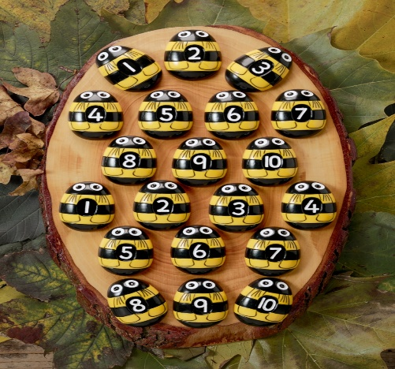

**Boots and Coats**

As its still rather wet and a bit chilly, please remember to bring in a coat and some boots for your child to wear during outdoor playtimes.

**Work Experience Student**

We are having a work experience student helping us during the week of 10th March. We hope Crystal will enjoy her week with us, getting to know the children and the staff.

**Easyfundraising**

If you are shopping online, then you can still help us raise funds for our Pre-school and After-school club by creating an account and visiting retailers through this site. Companies will donate a percentage of money to our Pre-school if you use this site whilst shopping online. You can access the link via our website or by visiting <http://www.easyfundraising.org.uk/?v=c>.

**Website**

Events, calendar dates and newsletters can be viewed on our website, as we update this regularly.

**Facebook page**

To keep up-to-date with events and news from our Pre-school then please take a look and like our face book page which can be found at <https://www.facebook.com/combepreschoolandafterschool>. Don’t forget to like us!

Thank You for taking the time to read our newsletter!

Best Wishes

From

Andrea, Lisa, Anne-Marie, Kate, Becky, Chloe, Lydia, Sophie and Harriet.