

Combe Pre-school Spring Term 3 Newsletter 2025

Happy New Year

We would like to wish you all a Happy and Peaceful New Year, and welcome you all back to the start on the new term’



Monday 6th January – Start of Spring Term 3 2025,

Friday 14th February – End of term,

Monday 17th February to Friday 21st February – Half Term Pre-school closed,

Monday 24th February – Start of term 3 at 8.50am,

Friday 4th April – End of term at 11.50am,

Monday 7th April to Monday 21st April – Easter Holidays Pre-school closed.

Tuesday 22nd April – Term 4 Starts at 8.50am.

Funding Forms

If you were given a Parental Declaration (funding) form, please make sure you return this by Mondy 6th January, to ensure your child gets funding for this term.

School Dinners

Please remember to order your child’s school dinners for the start of the new term.

Woodland Explorers

Our woodland Explorers sessions will start on Monday 13th January. Please ensure your child is dressed and ready to attend the session on their arrival. We may cancel these sessions due to bad weather, and if this happens, we will send a message via our Class Dojo app.

National Bird Day - Sunday 5th January 2025

As its National Bird Day on Sunday 5th January, we have planned some bird activities at pre-school during the first week of term. This important day is to make people aware about keeping birds safe, to appreciate the many types of birds we have and to support bird conservation. We will exploring different ways we can attract birds into our gardens such as birdboxes, birdbaths, and what plants we can grow in our gardens and bird feeders during the winter months to help support our local bird populations.

You can help to celebrate National Bird Day by:

1. Buying a bird identification book and try to name all birds you see on the day or during the week.
2. Turn your garden into a sanctuary! You can do this by making it look pleasing; adding simple decorations such as fruits and flowers that will attract birds. Keep a bowl of fresh, clean water along with bird food for hungry birds.
3. Donate some money to a bird sanctuary or charity near you to help in preserving birds that are at the risk of extinction.
4. You can make a birdbath, build a nest box, or purchase bird-friendly plants for your garden.

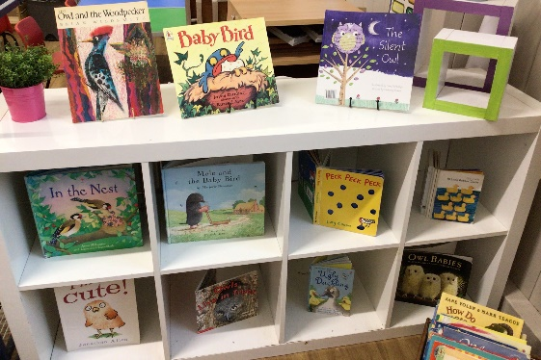

Boots and Coats

Now it’s starting to get really cold, so please ensure your child has a warm coat and some boots to play outside in the cold and wet weather.

Easyfundraising

If you are shopping online, then you can still help us raise funds for our Pre-school by creating an account and visiting retailers through this site. Companies will donate a percentage of money to our Pre-school if you use this site whilst shopping online. You can access the link via our website or by visiting <http://www.easyfundraising.org.uk/?v=c>.

Website

Events, calendar dates and newsletters can be viewed on our website, as we update this regularly.

Facebook page

To keep up-to-date with events and news from Pre-school, then please take a look and like our face book page which can be found at <https://www.facebook.com/combepreschoolandafterschool>. Don’t forget to like us!

Thank You for taking the time to read our newsletter!

Best Wishes

From

Andrea, Lisa, Anne-Marie, Kate, Becky, Chloe, Jo, Lydia, Sophie and Harriet.